Resolution sensitivity of tropical turbulent fluxes and precipitation in NorESM models

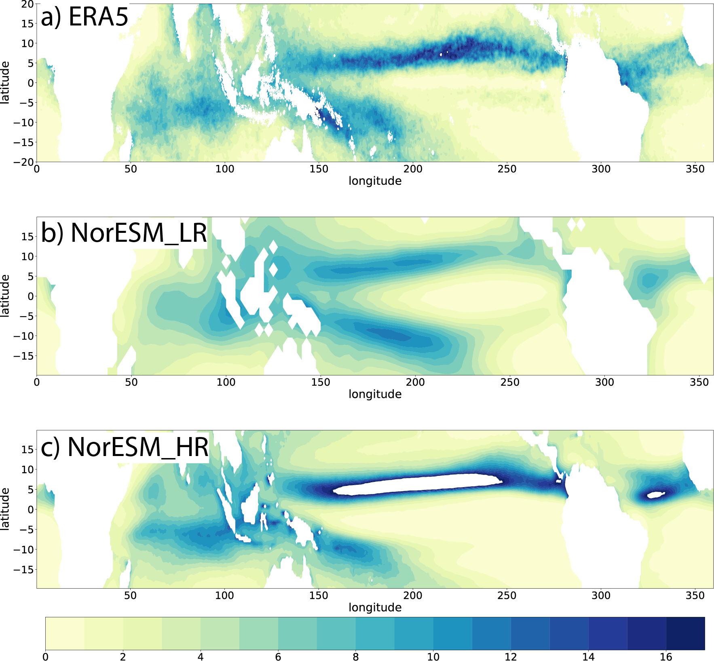

Fig. 1 Mean precipitation (unit: mm/day) in (a) ERA5, (b) NorESM_LR and (c) NorESM_HR.

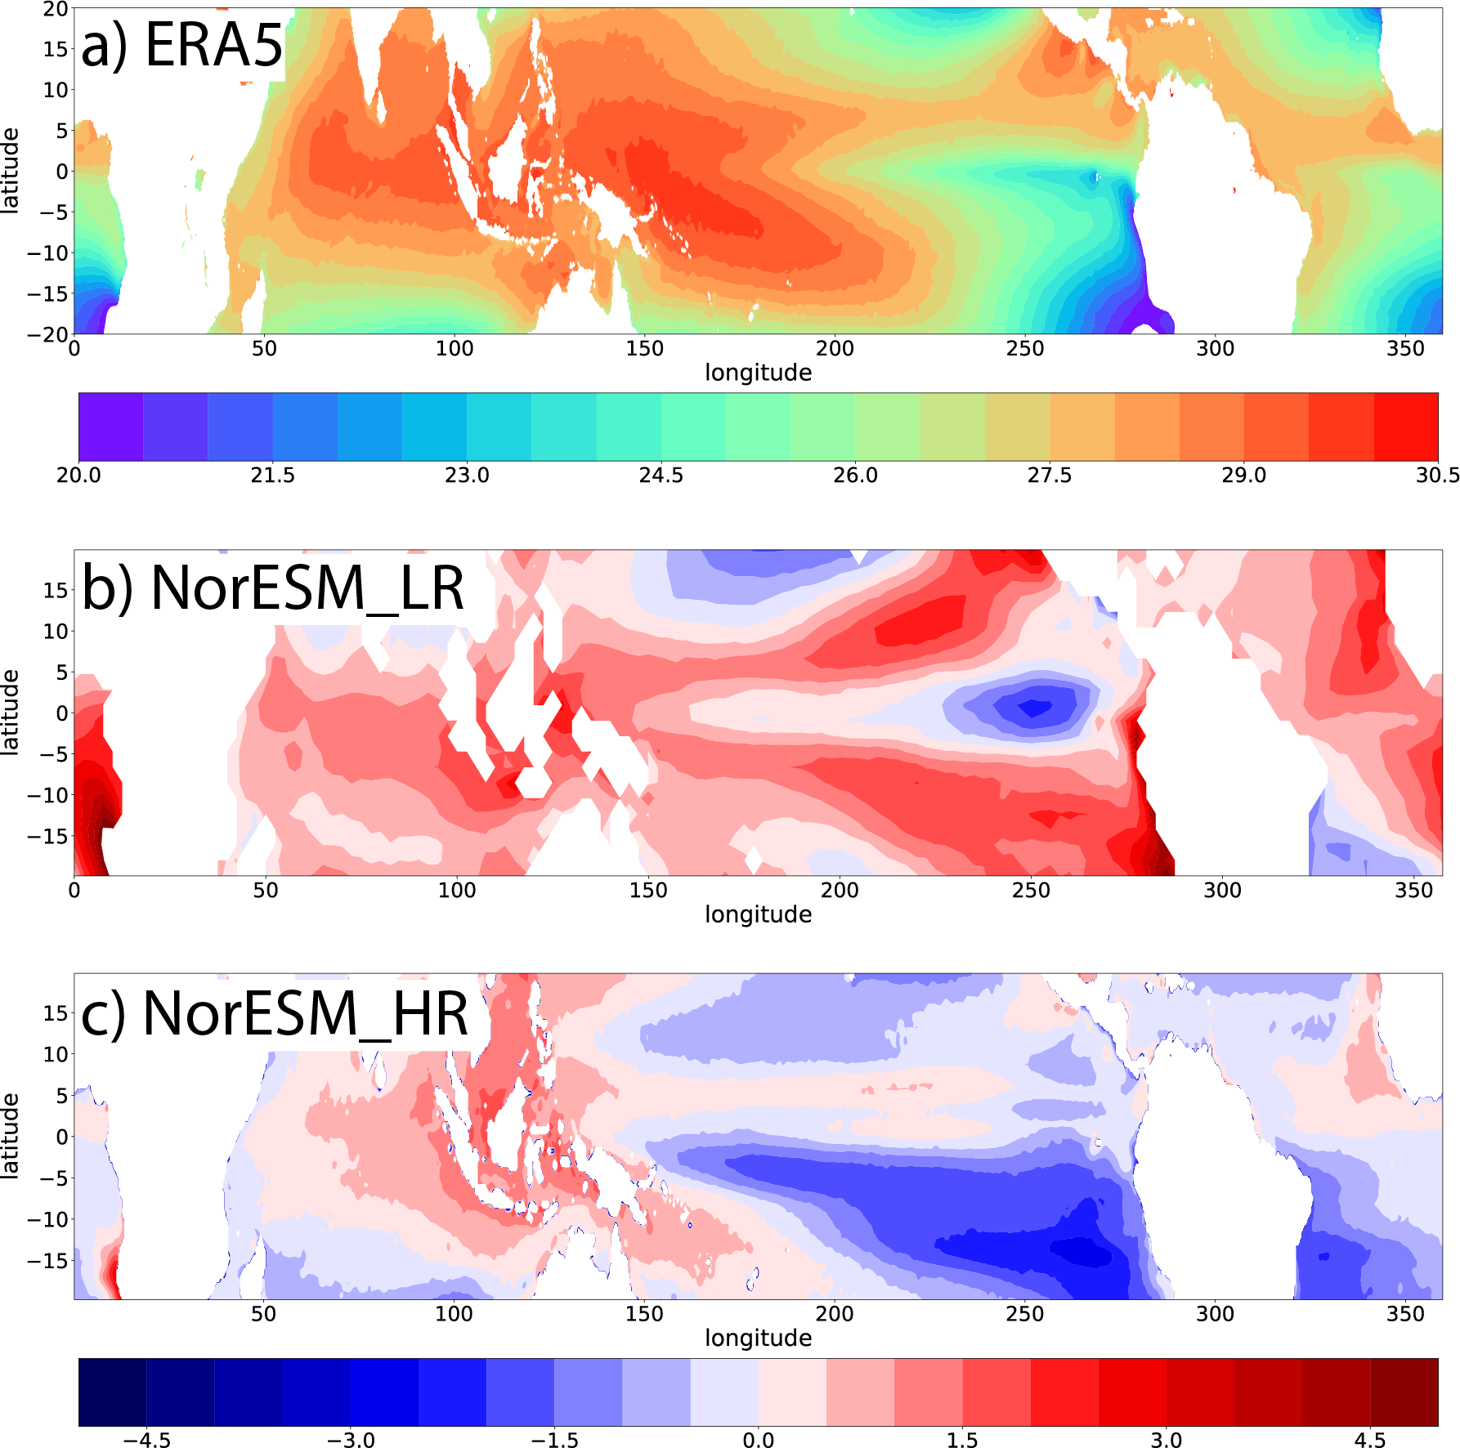

Fig.2 (a) Mean SST (°C) in ERA5, (b) and (c) Bias of SST NorESM_LR and NorESM_HR related to ERA5.

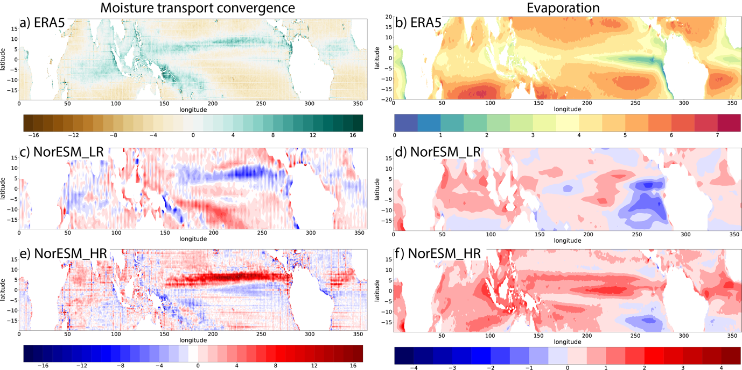

Fig3.Moisture transport convergence and Evaporation in ERA5 (a, b) and the biases in NorESM_LR (c, d) and the biases in NorESM_HR (e, f), in mm/day

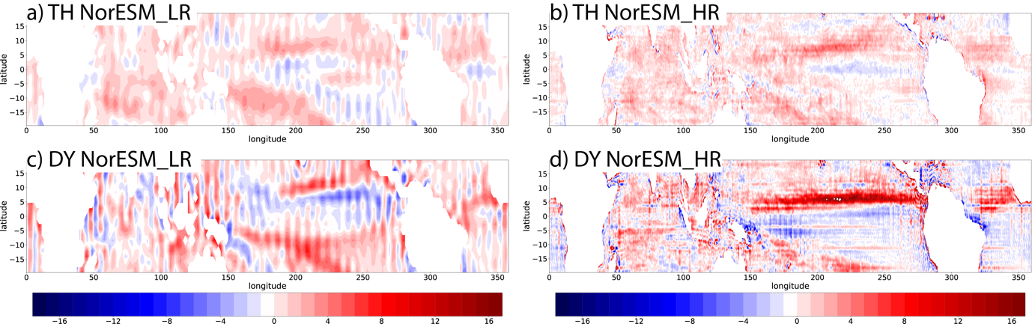

Fig.4 Bias in Thermodynamic and dynamic components of the moisture transport convergence, in mm/day

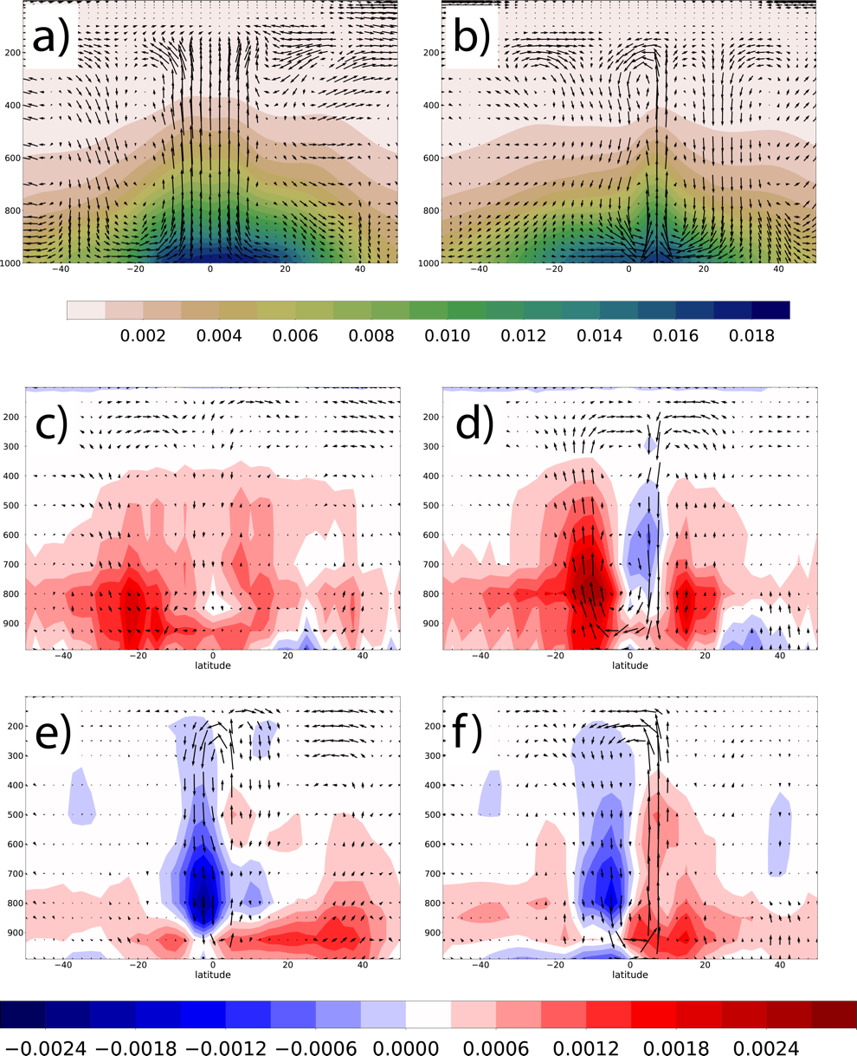

Fig. 5 (a) Hadley circulation (vector) and specific humidity (colors, kg/kg) in western pacific (120°E-180°E,.50°S-50°N) in ERA5. (b) Hadley circulation and specific humidity in eastern pacific (180°E-270°E, 50°S-50°N) in ERA5. (c) Biases of Hadley circulation and specific humidity in western pacific in NorESM_LR. (d) Biases of Hadley circulation and specific humidity in eastern pacific in NorESM_LR. (e)-(f) Same as (c)-(d) but for model NorESM_HR

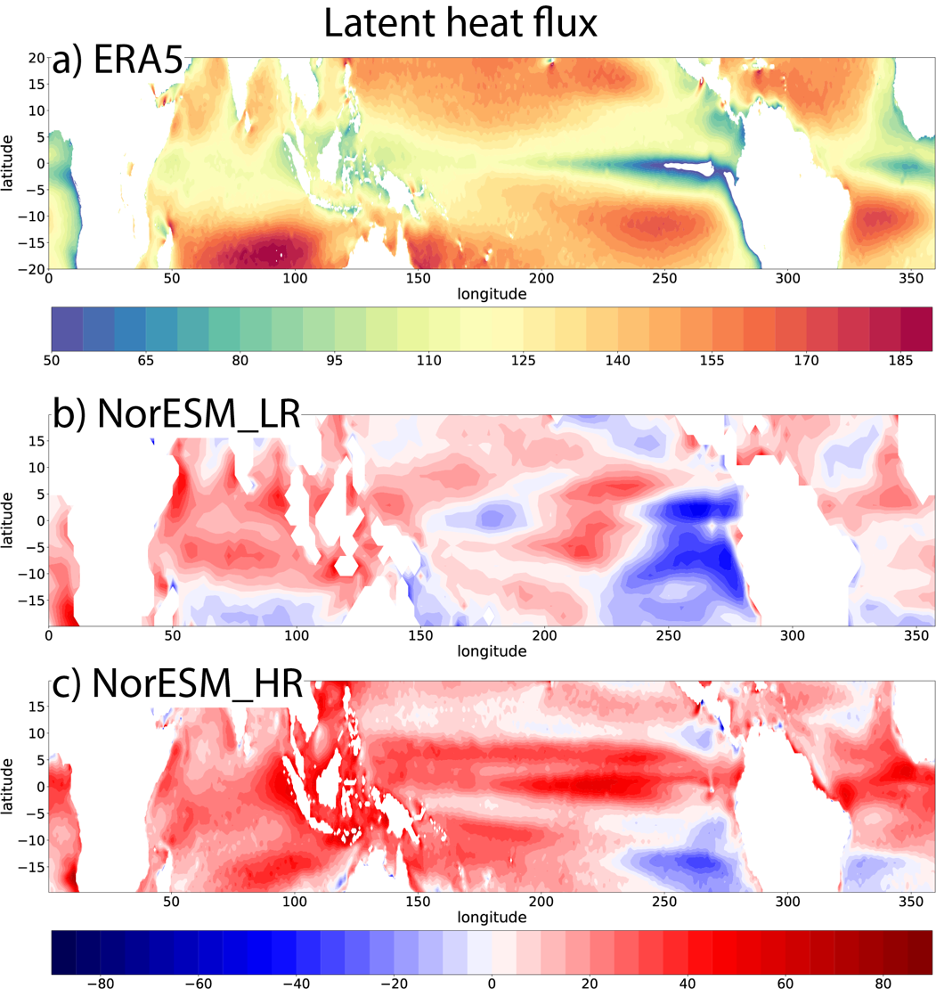

Fig.6 (a) Mean latent heat flux (W/m2) in ERA5. (b) Bias of latent heat flux in NorESM_LR. (c) Bias of latent heat flux in NorESM_HR

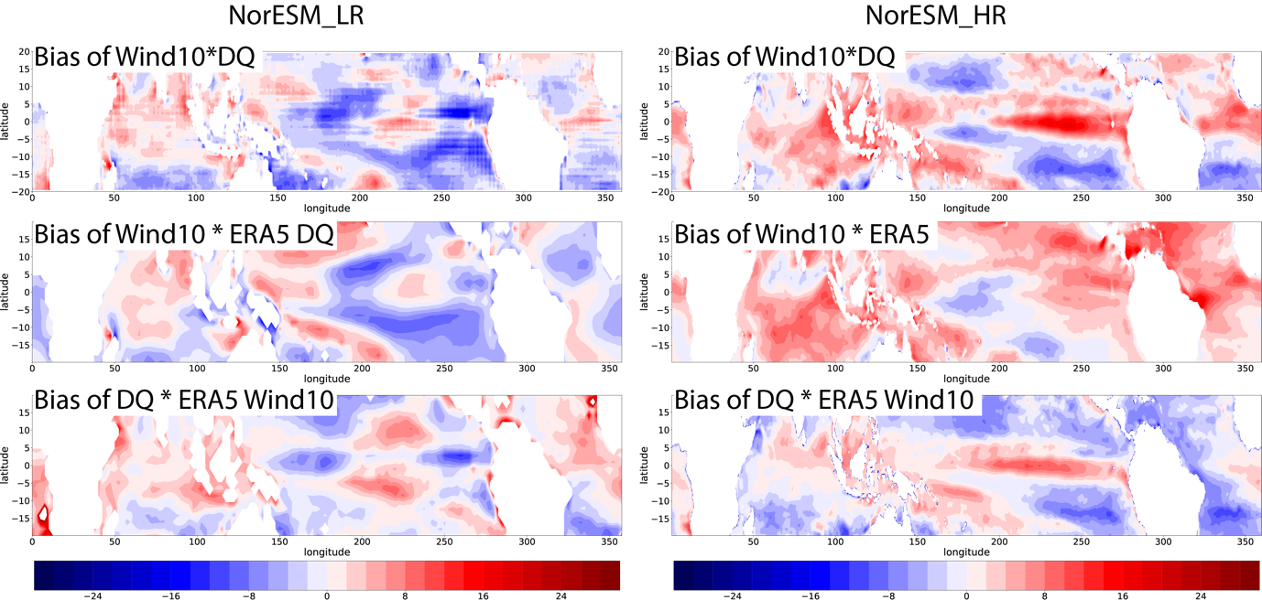

Fig. 7 bias contributed with wind and DQ

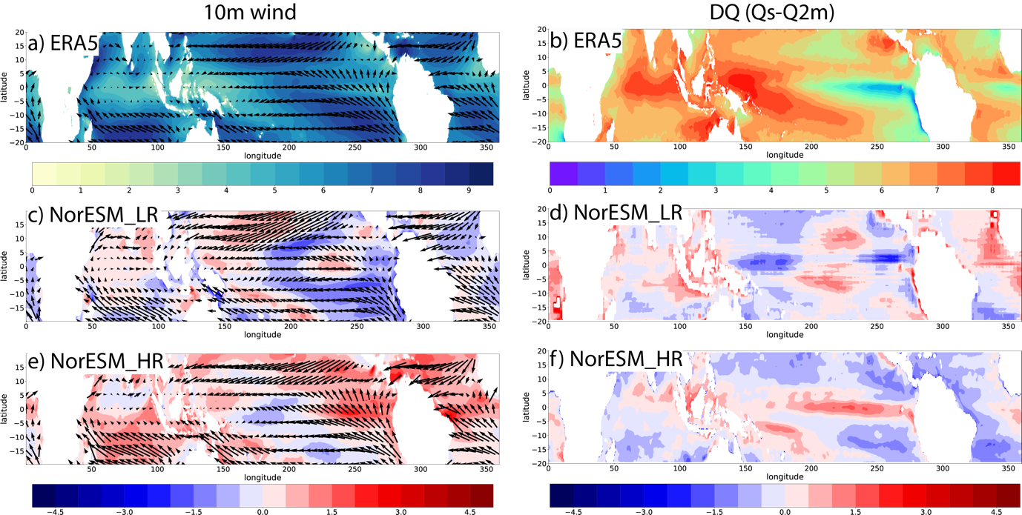

Fig. 8 10m wind and DQ and the bias

(a) Mean state of specific humidity between sea surface and 2m atmosphere (DQ=Qs-Q2m, g/kg) in ERA5. (c) and (d) Bias of DT and DQ in NorESM_LR. (e) and (f) Bias of DT and DQ in NorESM_HR.

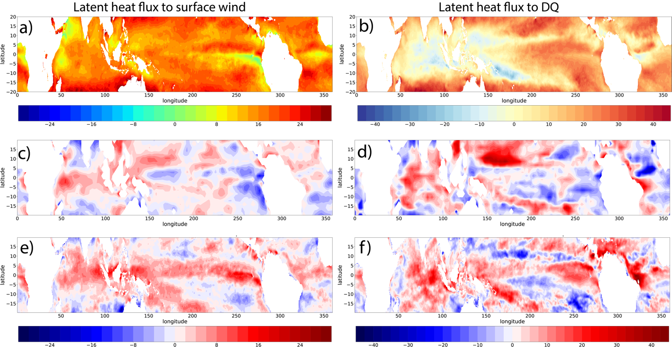

Fig.9 (a) Regression coefficient of latent heat flux to 10m wind in ERA5. (b) Regression coefficient of latent heat flux to DQ in ERA5. (c) Bias of regression coefficient of latent heat flux to 10m wind in NorESM_LR. (d) bias of regression coefficient of latent heat flux to DQ in NorESM_LR. (e) and (f) Similar as (c) and (d) but for NorESM_HR.

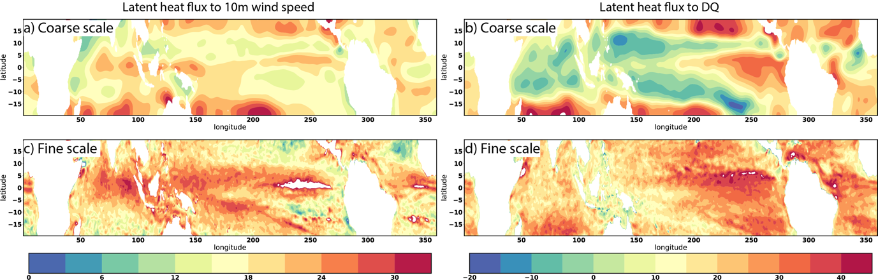

Fig.10 Regression coefficient in NorESM_HR. (a) Large-scale latent heat flux regressed to large-scale 10m wind. (b) Large-scale latent heat flux regressed to large-scale DQ. (c) Small-scale latent heat flux regressed to small-scale 10m wind speed. (d) Small-scale latent heat flux regressed to small-scale DQ. Large scale represents scale larger than 250km. Small scale is scale smaller than 250km.

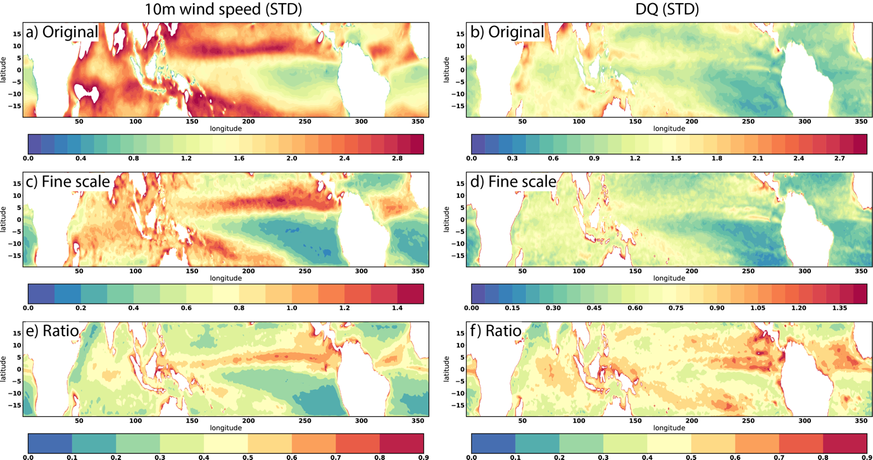

Fig.11 Standard deviation of 10m wind speed and DQ in NorESM_HR. (a) and (b) Original fields. (c) and (d) Small-scale fields. (e) and (f) Ratio of standard deviation in small-scale field to original field. Large scale represents scale larger than 250km. Small scale is scale smaller than 250km.

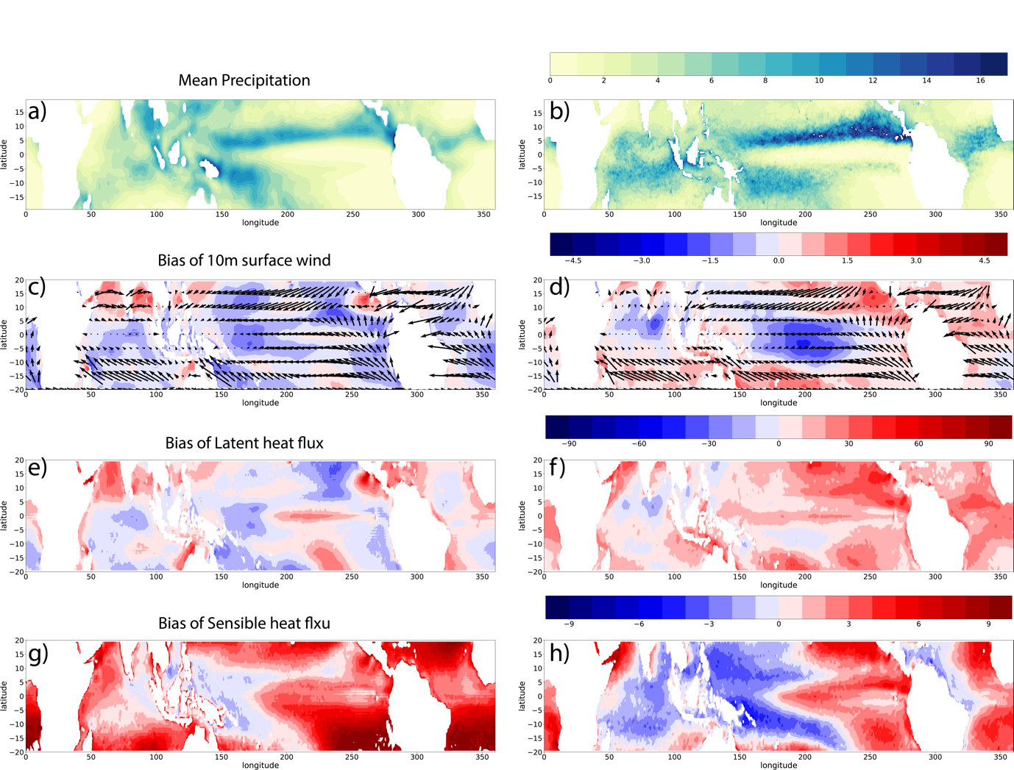

Fig.12 (a) Mean precipitation (mm/day) in CAM_LR. (b) Mean precipitation (mm/day) in CAM_HR. (c) and (d) Bias of 10m surface wind (vector) and 10m wind speed (colors, m/s) in CAM_LR and CAM_HR. (e) and (f) Bias of mean latent heat flux (W/m2) in CAM_HR and CAM_LR. (g) and (h) Bias of mean sensible heat flux (W/m2) in CAM_HR and CAM_LR.

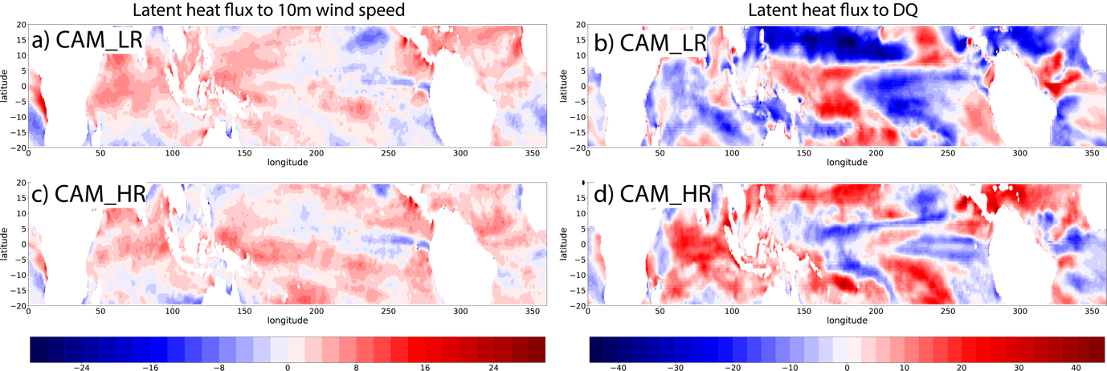

Fig. 13 (a, c) Regression coefficient of latent heat flux to 10m wind speed. (b, d) Regression coefficient of latent heat flux to DQ. (a, b) are for CAM_LR and (c, d) are for CAM_HR